**Sprint 1 Plan**

Titil: Summarize Everything

Team: Summarize Everything

End: Jan. 25, 2022

Revision: 1

Revision Date: Jan. 21, 2022

**Goal:**

Learn primary tools and techniques to be used for the project. Establish a fundamental concept of what our product will look like on the frontend.

**Task listing (Organized by user story):**

*User story 1:* As a backend engineer, I want at least four cleaned datasets so that we can begin

training.

*Task 1:* Select dataset and convert it into standard format. (**5 hr**)

*Total for user story 1:* ***5 hours***

*User story 2:* As a user, I want the machine learning model to be able to encapsulate a variety of

Inputs.

*Task 1*: Allow for .txt file uploads to the model. (**1.5 hr**)

*Total for user story 2:* ***1.5 hours***

*User story 3:* As a backend engineer, I want to be able to ingest and automatically train on a

given input dataset without much effort (build a trainer)

*Task 1:* Create a trainer which takes in a given input dataset and executes the

appropriate commands to train a model. (**1.5 hr**)

*Task 2:* Add more configuration options to the trainer. (**1 hr**)

*Total for user story 3:* ***2.5 hours***

*User story 4:* As a user, I want to have a functional interface that allows me to upload ‘.txt’ files

*Task 1:* Frontend engineers should also clear out potential spikes, learning

necessary technology such as react.js.

*Note:* Potentially useful: <https://ant.design/>

*Total for user story 4:* ***1.5 hours***

*User story 5:* As a user, I want to see the process status of summarizing.

*Task 1:* Create area on frontend interface displaying “*In process of summarizing*”,

“*Finished Summarizing*”, etc.(**1.5 hr**)

*Total for user story 5:* ***1.5 hours***

*User story 6:* As a user I want the summary output in bullet point or paragraph format

*Task 1:* Create a frontend environment to display bullet points or paragraphs.

*Total for user story 6:* ***1.5 hours***

**Team Roles:**

Jess Fan: Project Owner, Developer

Pushu Zhang: Scrum Master, Developer

Janet Zhu: Developer

Sebastian Medina: Developer

Victor Ho: Developer

**Initial task assignment:**

Jess Fan:

*User Story* -

*Initial Task* -

Pushu Zhang:

*User Story* -

*Initial Task* -

Janet Zhu:

*User Story* - 1, 3

*Initial Task* - 1.1, 3.1  
Sebastian Medina:

*User Story* - 2, 5, 6

*Initial Task* - 2.1, 5.1, 6.1

Victor Ho:

*User Story* - 1, 2, 3

*Initial Task* - 1.1, 2.1, 3.1

**Initial burnup chart:**

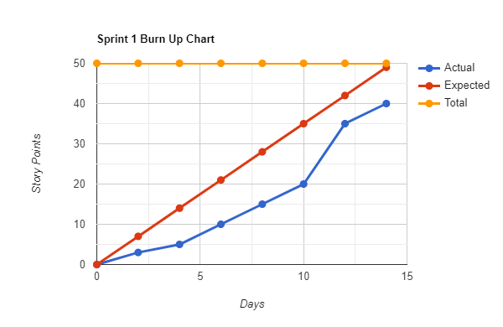

**Initial scrum board:**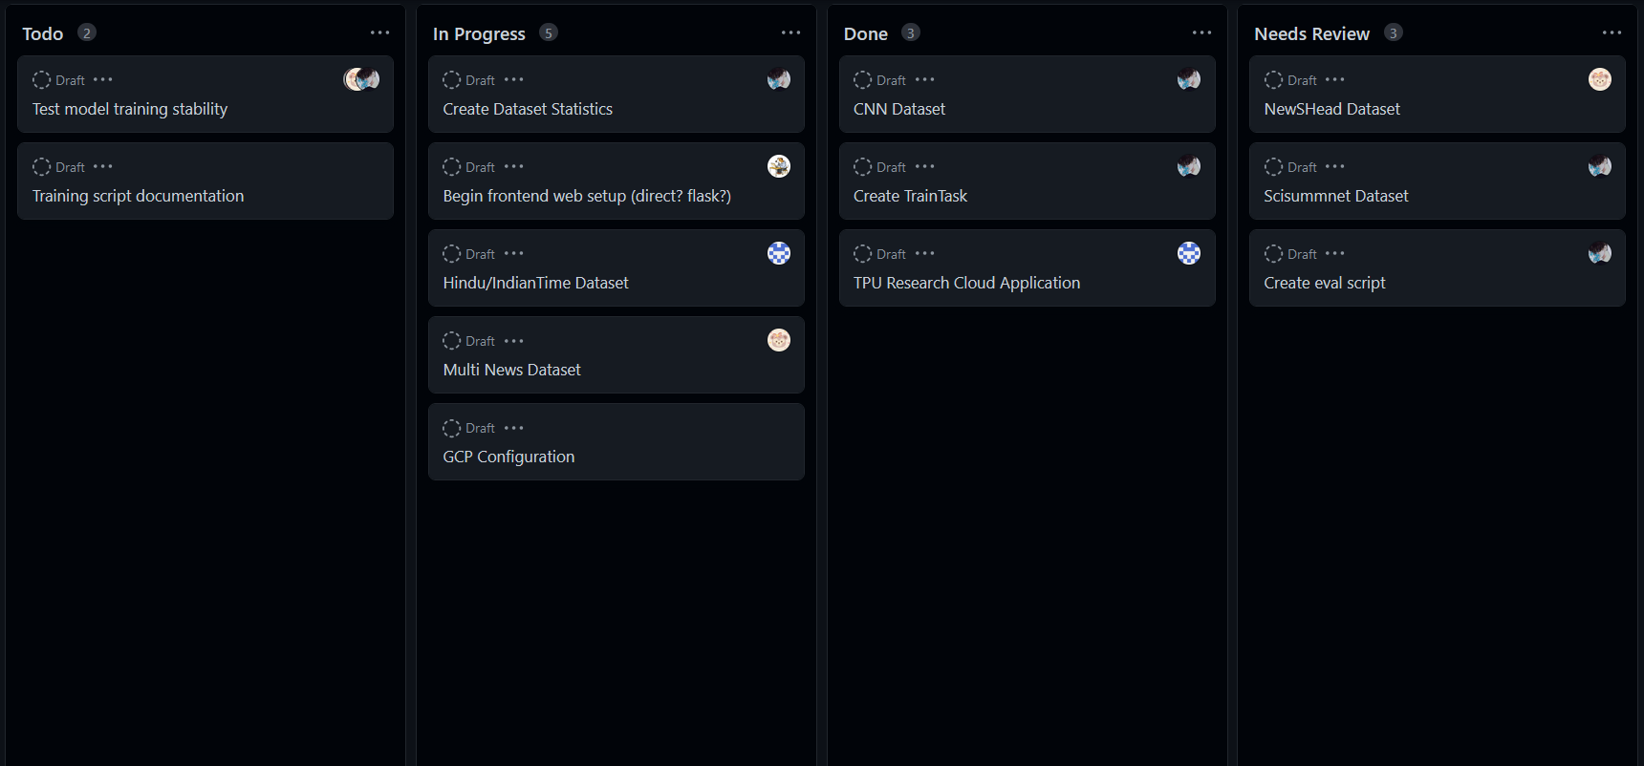

**Scrum times:**

* Monday: 8pm - 9pm
* Wednesday: 8pm - 9pm
* Friday: 3pm - 4:30pm [**TA meeting** 3pm - 4pm]